Eight-Pointed Star
# Source: AI Source: Provided by: [Data Path: Persons Table -> ID Column: 1, Name_En Column: Motasem Essam] -> From: [ChatGPT] on [7/25/2026]
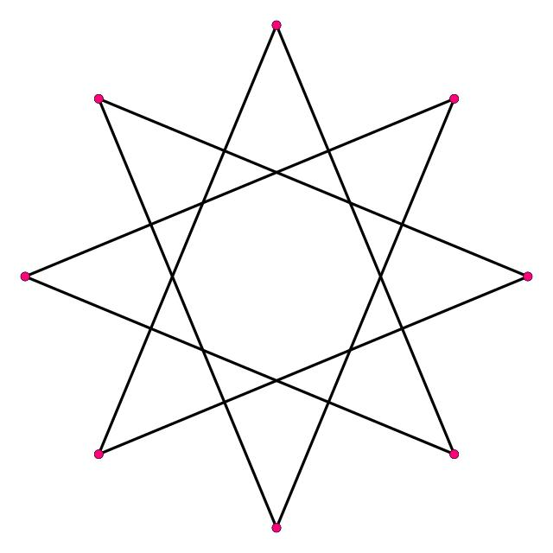
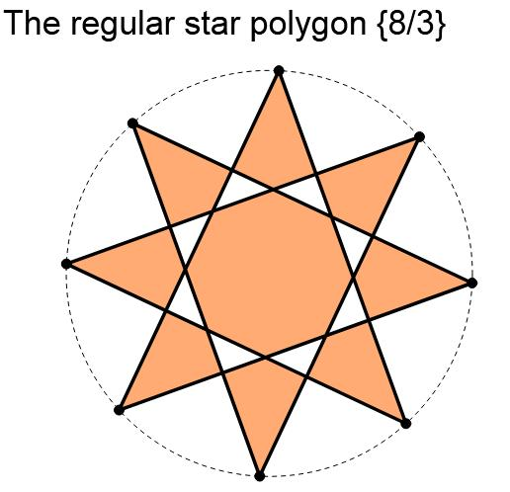
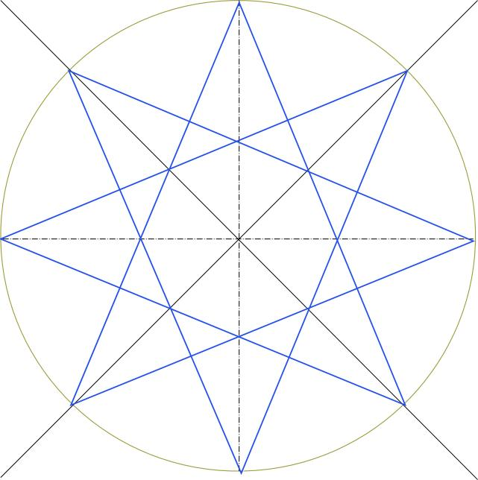
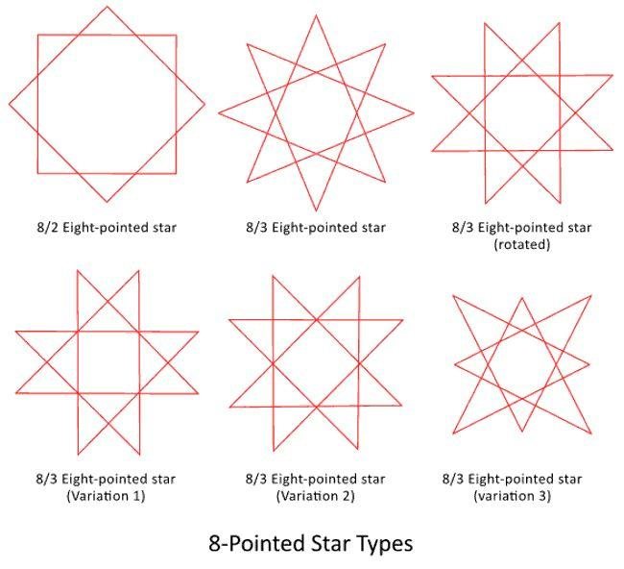

Definition
# Source: AI Source: Provided by: [Data Path: Persons Table -> ID Column: 1, Name_En Column: Motasem Essam] -> From: [ChatGPT] on [7/25/2026]
An Eight-Pointed Star is a star-shaped geometric figure with eight outer points.
When its boundary is constructed from straight line segments that cross one another, it can form a self-intersecting star polygon, called an octagram.
A regular octagram can be represented using Schläfli notation:
$$\left\{8/k\right\}$$
where:
- $8$represents the eight vertices of the underlying regular octagon.
- $k$represents the step size, indicating how many vertices are advanced when connecting consecutive vertices.
A common regular eight-pointed star polygon is:
$$\boxed{\left\{8/3\right\}}$$

Purpose
# Source: AI Source: Provided by: [Data Path: Persons Table -> ID Column: 1, Name_En Column: Motasem Essam] -> From: [ChatGPT] on [7/25/2026]
The Eight-Pointed Star is useful for:
- Studying self-intersecting polygons.
- Studying regular star polygons.
- Demonstrating rotational symmetry.
- Studying reflection symmetry.
- Connecting regular polygons with star-shaped figures.
- Exploring geometric construction and intersection.
- Understanding the relationship between an octagon and an octagram.

Fundamental Elements
# Source: AI Source: Provided by: [Data Path: Persons Table -> ID Column: 1, Name_En Column: Motasem Essam] -> From: [ChatGPT] on [7/25/2026]
A regular eight-pointed star has:
- 8 outer points.
- 8 principal vertices.
- An underlying regular octagon.
- Straight line segments connecting the vertices.
- Self-intersection points in its star-polygon form.
- 8-fold rotational symmetry.
- 8 reflection axes in the regular form.
The full rotation around the center is:
$${360}^{∘}$$
Since there are eight equally spaced vertices:
$$\frac{{360}^{∘}}{8}={45}^{∘}$$
Therefore, the basic rotational angle is:
$$\boxed{{45}^{∘}}$$

Mathematical Representation
Regular Octagram
A common regular eight-pointed star polygon is:
$$\boxed{\left\{8/3\right\}}$$
It is constructed by connecting every third vertex of a regular octagon.
For example, label the octagon:
$$A,B,C,D,E,F,G,H$$
Then construct:
$$A→D→G→B→E→H→C→F→A$$
This produces the regular octagram $\left\{8/3\right\}$.

Important Note About $8/2$
# Source: AI Source: Provided by: [Data Path: Persons Table -> ID Column: 1, Name_En Column: Motasem Essam] -> From: [ChatGPT] on [7/25/2026]
The notation:
$$\left\{8/2\right\}$$
does not produce one continuous eight-vertex star polygon.
Because:
$$gcd⁡\left(8 , 2\right)=2$$
the construction splits into two separate polygons.
Specifically:
$$A→C→E→G→A$$
and
$$B→D→F→H→B$$
Each component is a square.
Therefore, the regular single-path octagram is commonly represented by:
$$\boxed{\left\{8/3\right\}}$$

Construction
# Source: AI Source: Provided by: [Data Path: Persons Table -> ID Column: 1, Name_En Column: Motasem Essam] -> From: [ChatGPT] on [7/25/2026]
To construct a regular eight-pointed star:
Step 1: Draw a regular octagon
Create a regular octagon with vertices:
$$A,B,C,D,E,F,G,H$$
Step 2: Number the vertices
Number them consecutively around the circle.
Step 3: Choose a step size
For the common octagram:
$$k=3$$
Step 4: Connect every third vertex
Connect:
$$A→D \\ D→G \\ G→B \\ B→E \\ E→H \\ H→C \\ C→F \\ F→A$$
The resulting figure is:
$$\boxed{\left\{8/3\right\}}$$

Symmetry
# Source: AI Source: Provided by: [Data Path: Persons Table -> ID Column: 1, Name_En Column: Motasem Essam] -> From: [ChatGPT] on [7/25/2026]
A regular eight-pointed star has 8-fold rotational symmetry.
The smallest positive rotation that maps the figure onto itself is:
$$θ=\frac{{360}^{∘}}{8}$$
Therefore:
$$\boxed{θ={45}^{∘}}$$
It also has:
$$\boxed{8}$$
reflection axes.
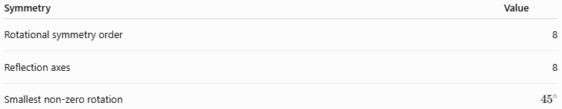
Symmetry | Value
Rotational symmetry order | 8
Reflection axes | 8
Smallest non-zero rotation | $${45}^{∘}$$

Perimeter
# Source: AI Source: Provided by: [Data Path: Persons Table -> ID Column: 1, Name_En Column: Motasem Essam] -> From: [ChatGPT] on [7/25/2026]
If the eight segments forming the star path have equal length $s$, then the total length of the star path is:
$$P=8s$$
Example
If:
$$s=5\text{ cm}$$
then:
$$P=8\left(5\right) \\ \boxed{P=40\text{ cm}}$$
Note: For a self-intersecting star, this is the total length of its eight drawn segments. It should not automatically be confused with the perimeter of a filled star-shaped region.

Angles
# Source: AI Source: Provided by: [Data Path: Persons Table -> ID Column: 1, Name_En Column: Motasem Essam] -> From: [ChatGPT] on [7/25/2026]
The eight vertices of the underlying regular octagon are separated by:
$$\frac{{360}^{∘}}{8}={45}^{∘}$$
Thus:
$$\boxed{{45}^{∘}}$$
is the central angle between consecutive vertices.
The exact angles formed at the intersections and star tips depend on the particular octagram construction.
Therefore, the ordinary interior-angle formula for a simple octagon should not simply be applied to the self-intersecting star boundary.

Example 1: Rotational Symmetry
# Source: AI Source: Provided by: [Data Path: Persons Table -> ID Column: 1, Name_En Column: Motasem Essam] -> From: [ChatGPT] on [7/25/2026]
Find the smallest rotation that maps a regular eight-pointed star onto itself.
$$θ=\frac{{360}^{∘}}{8} \\ \boxed{θ={45}^{∘}}$$
So the figure matches itself after rotations of:
$${45}^{∘}, {90}^{∘}, {135}^{∘}, {180}^{∘},…$$

Example 2: Perimeter
# Source: AI Source: Provided by: [Data Path: Persons Table -> ID Column: 1, Name_En Column: Motasem Essam] -> From: [ChatGPT] on [7/25/2026]
Suppose each of the eight star-path segments is:
$$7\text{ cm}$$
Then:
$$P=8s \\ P=8\left(7\right) \\ \boxed{P=56\text{ cm}}$$

Example 3: Constructing an Octagram
# Source: AI Source: Provided by: [Data Path: Persons Table -> ID Column: 1, Name_En Column: Motasem Essam] -> From: [ChatGPT] on [7/25/2026]
Given a regular octagon:
$$A,B,C,D,E,F,G,H$$
connect every third vertex:
$$A→D→G→B→E→H→C→F→A$$
The result is:
$$\boxed{\left\{8/3\right\}}$$
which is a regular eight-vertex star polygon.

Relationship with Related Concepts
# Source: AI Source: Provided by: [Data Path: Persons Table -> ID Column: 1, Name_En Column: Motasem Essam] -> From: [ChatGPT] on [7/25/2026]
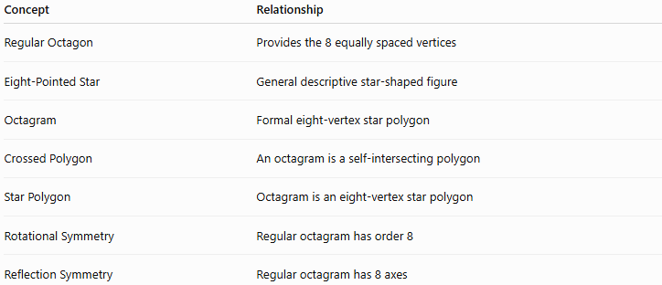
Concept | Relationship
Regular Octagon | Provides the 8 equally spaced vertices
Eight-Pointed Star | General descriptive star-shaped figure
Octagram | Formal eight-vertex star polygon
Crossed Polygon | An octagram is a self-intersecting polygon
Star Polygon | Octagram is an eight-vertex star polygon
Rotational Symmetry | Regular octagram has order 8
Reflection Symmetry | Regular octagram has 8 axes

Eight-Pointed Star vs Regular Octagon
# Source: AI Source: Provided by: [Data Path: Persons Table -> ID Column: 1, Name_En Column: Motasem Essam] -> From: [ChatGPT] on [7/25/2026]
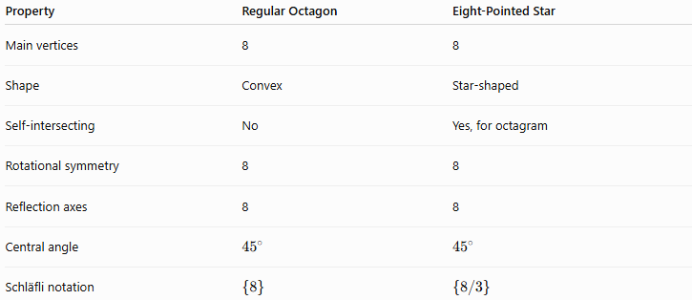
Property | Regular Octagon | Eight-Pointed Star
Main vertices | 8 | 8
Shape | Convex | Star-shaped
Self-intersecting | No | Yes, for octagram
Rotational symmetry | 8 | 8
Reflection axes | 8 | 8
Central angle | $${45}^{∘}$$ | $${45}^{∘}$$
Schläfli notation | $$\left\{8\right\}$$ | $$\left\{8/3\right\}$$

Eight-Pointed Star vs Seven-Pointed Star
# Source: AI Source: Provided by: [Data Path: Persons Table -> ID Column: 1, Name_En Column: Motasem Essam] -> From: [ChatGPT] on [7/25/2026]
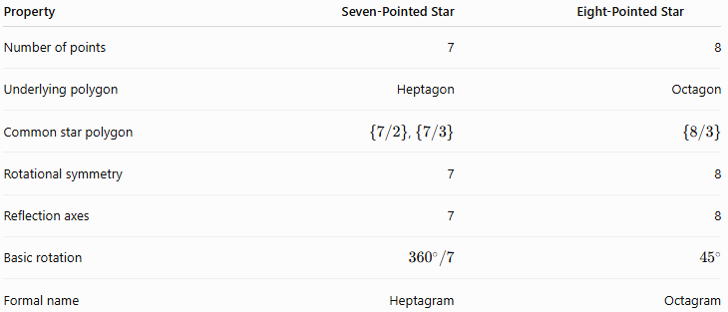
Property | Seven-Pointed Star | Eight-Pointed Star
Number of points | 7 | 8
Underlying polygon | Heptagon | Octagon
Common star polygon | $\left\{7/2\right\}$, $\left\{7/3\right\}$ | $$\left\{8/3\right\}$$
Rotational symmetry | 7 | 8
Reflection axes | 7 | 8
Basic rotation | $${360}^{∘}/7$$ | $${45}^{∘}$$
Formal name | Heptagram | Octagram

Taxonomy
# Source: AI Source: Provided by: [Data Path: Persons Table -> ID Column: 1, Name_En Column: Motasem Essam] -> From: [ChatGPT] on [7/25/2026]
For your existing Crossed Star Shapes hierarchy, I recommend:
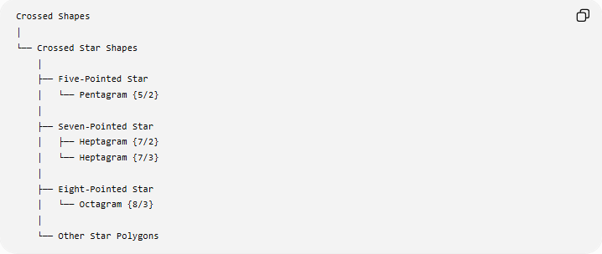
Crossed Shapes
│
└── Crossed Star Shapes
│
├── Five-Pointed Star
│ └── Pentagram {5/2}
│
├── Seven-Pointed Star
│ ├── Heptagram {7/2}
│ └── Heptagram {7/3}
│
├── Eight-Pointed Star
│ └── Octagram {8/3}
│
└── Other Star Polygons
More formally:
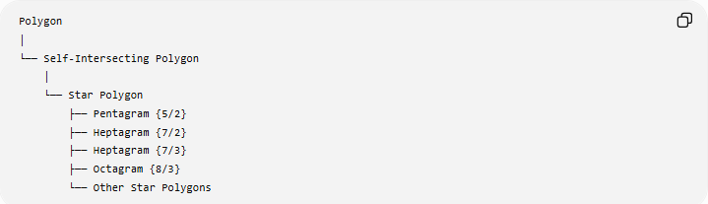
Polygon
│
└── Self-Intersecting Polygon
│
└── Star Polygon
├── Pentagram {5/2}
├── Heptagram {7/2}
├── Heptagram {7/3}
├── Octagram {8/3}
└── Other Star Polygons

Real-World Applications
# Source: AI Source: Provided by: [Data Path: Persons Table -> ID Column: 1, Name_En Column: Motasem Essam] -> From: [ChatGPT] on [7/25/2026]
Eight-pointed stars appear in:
- Decorative geometric patterns.
- Architecture and ornamentation.
- Tile and mosaic designs.
- Textile patterns.
- Graphic design.
- Mathematical illustrations.
- Symmetry studies.
- Religious and cultural geometric artwork.

Advantages
# Source: AI Source: Provided by: [Data Path: Persons Table -> ID Column: 1, Name_En Column: Motasem Essam] -> From: [ChatGPT] on [7/25/2026]
- Provides a clear example of a self-intersecting polygon.
- Demonstrates 8-fold rotational symmetry.
- Connects an octagon with a star polygon.
- Useful for studying geometric construction.
- Introduces Schläfli notation.
- Provides a visually clear example of repeated symmetry.

Limitations
# Source: AI Source: Provided by: [Data Path: Persons Table -> ID Column: 1, Name_En Column: Motasem Essam] -> From: [ChatGPT] on [7/25/2026]
- Eight-pointed star is a descriptive term and does not uniquely define one mathematical figure.
- Different constructions can produce different star shapes.
- $\left\{8/2\right\}$does not form one continuous star polygon.
- Area calculations require care because the edges intersect.
- Ordinary simple-polygon interior-angle formulas cannot automatically be applied to the star boundary.

Key Points
# Source: AI Source: Provided by: [Data Path: Persons Table -> ID Column: 1, Name_En Column: Motasem Essam] -> From: [ChatGPT] on [7/25/2026]
- An Eight-Pointed Star has 8 outer points.
- A formal self-intersecting eight-pointed star polygon is called an octagram.
- A common regular octagram is:
$$\boxed{\left\{8/3\right\}}$$
- The underlying polygon is a regular octagon.
- The basic central angle is:
$$\boxed{{45}^{∘}}$$
- It has 8-fold rotational symmetry.
- It has 8 reflection axes in the regular form.
- $\left\{8/2\right\}$produces two separate squares rather than one continuous star.
- It belongs under:
$$\boxed{\text{Crossed Shapes}→\text{Crossed Star Shapes}→\text{Eight-Pointed Star}}$$

Conclusion
# Source: AI Source: Provided by: [Data Path: Persons Table -> ID Column: 1, Name_En Column: Motasem Essam] -> From: [ChatGPT] on [7/25/2026]
The Eight-Pointed Star is a star-shaped figure with eight points. Its formal self-intersecting polygonal form is an octagram, with the common regular construction represented by $\left\{8/3\right\}$. It is based on the vertices of a regular octagon and possesses 8-fold rotational symmetry, making it an important example of a regular crossed star polygon.

